Publication: Bon Appétit
HED: Your New Favorite Holiday Cookie Starts with Brown Butter

DEK: Thick, chewy, perfectly golden at the edges, and filled with rich chocolate–this cookie recipe is incomparable to others. Here’s how my neighbor, Gavin McKinnon, curated his recipe, and the surprising steps that make this cookie recipe one to bring to the holidays.

In the mood to make chocolate chip cookies, but are sick of the traditional, first-click, recipes you see when searching for one? Thinking, “Hmm, I hate baking but want to wow my family at Thanksgiving this year with a dessert.” You have stumbled upon a recipe unlike the rest, for all the right reasons, that will leave your relatives wanting more.

Gavin McKinnon, my neighbor for the last three years, has spent plenty of time perfecting his take on the classic cookie. “I used to watch Bon Appétit Test Kitchen videos, and the Brown Butter Chocolate Chip Cookie with Toffee Bits was so good I revolved my recipe around that one.” His master recipe has resulted in a cookie that checks all the boxes. Crisp edges, a soft center, and melty pockets of rich chocolate in every bite. “A big cookie is always memorable–that’s why I use an ice cream scoop for mine.”

Here’s what makes his version special and how you can bake them at home.

The Essentials
- 1 c. (200 g) granulated sugar
- 1 ¼ c. (275 g) lightly packed dark brown sugar
- 1 ½ c. (3 sticks) unsalted butter
- 2 eggs
- 1 tsp. vanilla extract
- 3 ½ c. (420 g) flour
- 2 tbsp. milk powder
- 1 tsp. salt
- 1 ½ tsp. baking powder
- 1 ¼ tsp. baking soda
- ​​11.5 oz. package semi-sweet chocolate chips

Brown Butter is a Must
Instead of using regular melted butter, Gavin browns it first. “Brown butter is probably the biggest change in terms of end flavor because it makes the whole cookie taste more ‘caramel-ly’-and it makes the batter a little darker too, which helps with presentation.” There are not many other ways to explain it besides having to try it if you have not.

Milk Powder
A small addition that makes a massive impact. “Milk powder is milk solids, so in the oven they caramelize and kind of enhance the flavor from the brown butter,” Gavin says. “It also absorbs extra moisture so they stay chewy for longer, but get crispy on the outside when the milk solids toast.” This step takes the cookies to the next level; do not overlook it.

Chill the Dough
Yes, this step adds time, but yes, it matters. Gavin says he chills his dough for a few hours or overnight. “Resting the dough cannot be skipped. Because of the high amount of fat, the dough needs to rehydrate before baking.” Since this recipe is freezer-friendly, you can bake just a few at a time and save the rest. “That was the whole idea–a recipe that gets even better from frozen, so you can have them made whenever you want.”

Don’t Overbake
Finding the right baking time was a process. “It took me forever to figure out, but higher temp and shorter time for crispy, lower and slower for chewy.” The visual cue he swears by? “Usually, the tops of the cookies have little ridges from where the dough didn’t fill the scoop. You can almost peek into the center of the cookie. Once the dough in between the ridges is no longer shiny, and the top starts to get a little golden brown, then they’re ready to come out.”

The Gooey Center Trick
For peak gooeyness, bake them at 375º for about 15 mins. The secret pro tip that isn’t in the recipe is to “Drop the pan onto the counter from 6” or so high a couple times, it flattens the hot cookies out and makes them a little more dense and super chewy.”

Instructions
Step 1: Brown 2 sticks of butter: Place 2 sticks in a small saucepan over medium heat. Melt and let boil. Once boiling vigorously, begin stirring constantly with a rubber spatula for 5-7 minutes. This way, the water will boil off, and the top surface will foam. Continue to cook until the milk solids begin to brown to a deep caramel color. Once you reach the desired level of browning, remove from the heat and pour into a heatproof bowl immediately to stop cooking.

Step 2: Cool butter 5-10 mins, slowly add third stick of butter (cold, cubed) into the hot brown
butter. Stir constantly to prevent brown butter from foaming up. Continue cooling another 10- 15 mins

Step 3: Combine melted butter and both sugars

Step 4: Add eggs and vanilla, mix vigorously for 2-3 minutes. The mixture should become a far lighter brown and will hold ribbons as you stir.

Step 5: Fold in dry ingredients (pulse on low if using a stand mixer) until barely combined. Add chocolate chips and finish mixing. Dough may look greasy; this is normal

Step 6: Using a large (2 oz) cookie scoop, scoop dough onto a parchment-lined tray before placing in the freezer for at least 1 hour (even better if you can leave them overnight)

Step 7: Bake cookies at 375ºF for 15-18 minutes

Social Media Post
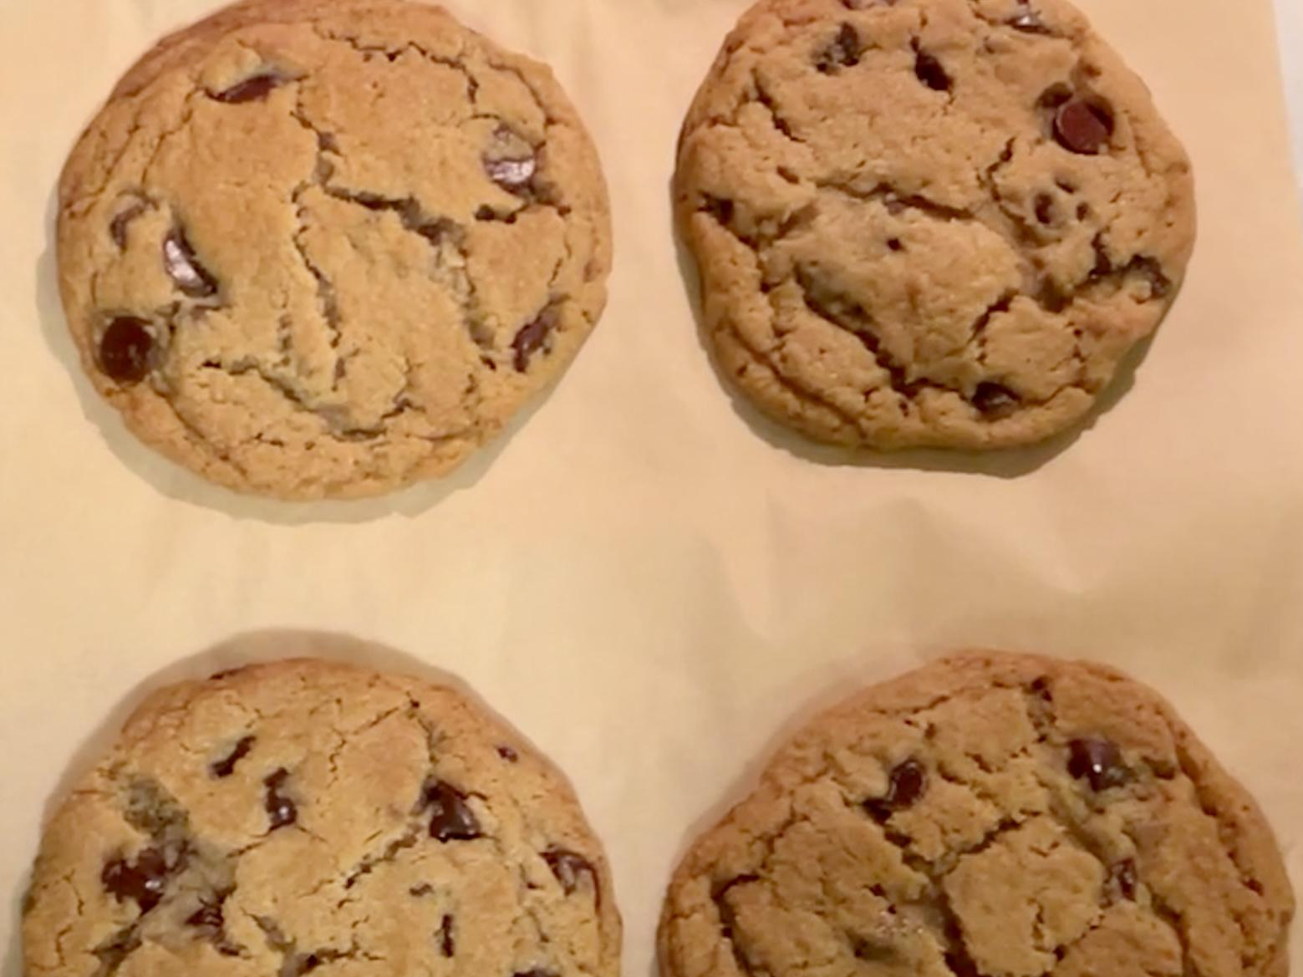
Caption: These cookies are actually insane. Thick, chewy, packed with chocolate, and yes, my neighbor Gavin finally dropped the recipe. Save this post so you can pretend you didn’t eat half the dough before baking. Perfect for the holiday season if you’re looking to bring a dessert that everyone will love!

